**Tugas QA 8-2**

1. Cypress Test

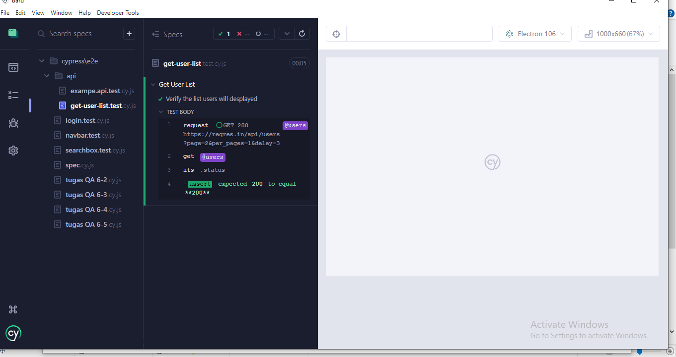

1. Postman Test

